Seabird Apps User Personas

Sean Cann



# **Drew M. ‘20 (real user)**

*Home state: New Hampshire*

Drew recently entered Dartmouth College in 16F as a freshman. Coming into this entirely new environment, Drew had no idea how things at Dartmouth work. She discovered the Dartmouth Student app by Seabird Apps, and at first used it to get a good feel for what the college is like, using the Map module the most (25% of her actions) as well as the Schedule module (20% of actions). As she became more of an expert Dartmouth student, she began using the app for different things. Now, she uses it primarily to check what the menus are at the dining facilities (45% of actions).



# **Lauren S. ‘17 (real user)**

*Home state: Massachusetts*

Lauren is a senior who has been consistently using the Dartmouth Student app since the beginning of 16F. She primarily uses it to check what events are happening on campus (45% of actions). She likes the events system a lot, and has even submitted events for her organization a few times.

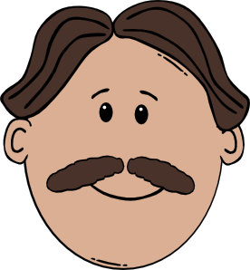

# **Harold W. ‘76 (fictional user)**

*Home state: New York*

Harold is an alum of Kent State University. He wants to keep in touch with what’s happening at his alma mater. He likes using the (fictional) KSU Alumni app by Seabird Apps primarily to see the campus news. He also has used it a few times to look up other KSU alumni living in NYC through the integrated alumni directory.



# **Jacob P. (fictional user)**

*Home state: Ohio*

Jacob is a senior in high school, searching for colleges. He’s really interested in both Kenyon College and Denison College. He wants to get enough information on each to have a good feel for each college before making his decision. While researching Kenyon before a visit, he discovered the Kenyon College app by Seabird Apps, built for both prospective and current students. He downloaded it and looked through the basic information about the history of the college and what life is like for a Kenyon student. Later, he also used the campus map feature to navigate among the buildings during his visit.